**Installing GNS3 on Ubuntu**

# **GNS3 Installation in Ubuntu**

It is important to see this link about GNS3 installation. It became pretty much easy to install GNS3 in ubuntu **https://www.youtube.com/watch?v=sXqh3gj8log**

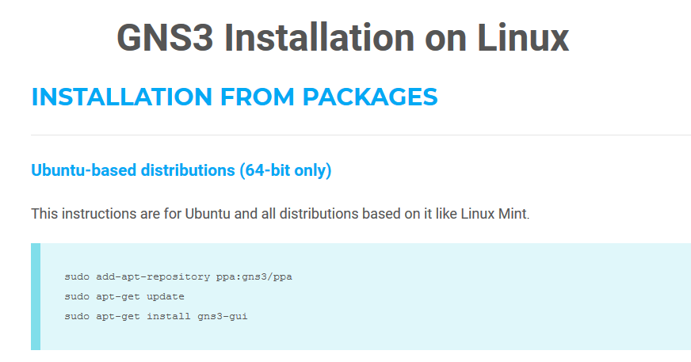

# **Terminal**

Open terminal and type in commands from website

* 1. sudo add-apt-repository ppa:gns3/ppa

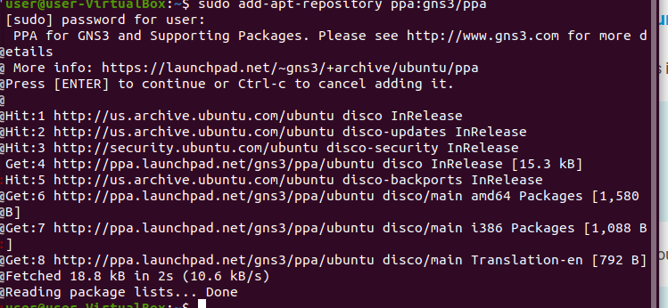

* 1. sudo apt-get update
  2. sudo apt-get install gns3-gui

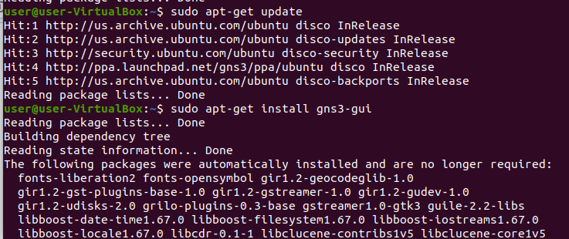

Enter this command $ GNS3 then main gns3 window open in the Ubuntu

# **Setting up GNS3**

* 1. Find GNS3 in the app section

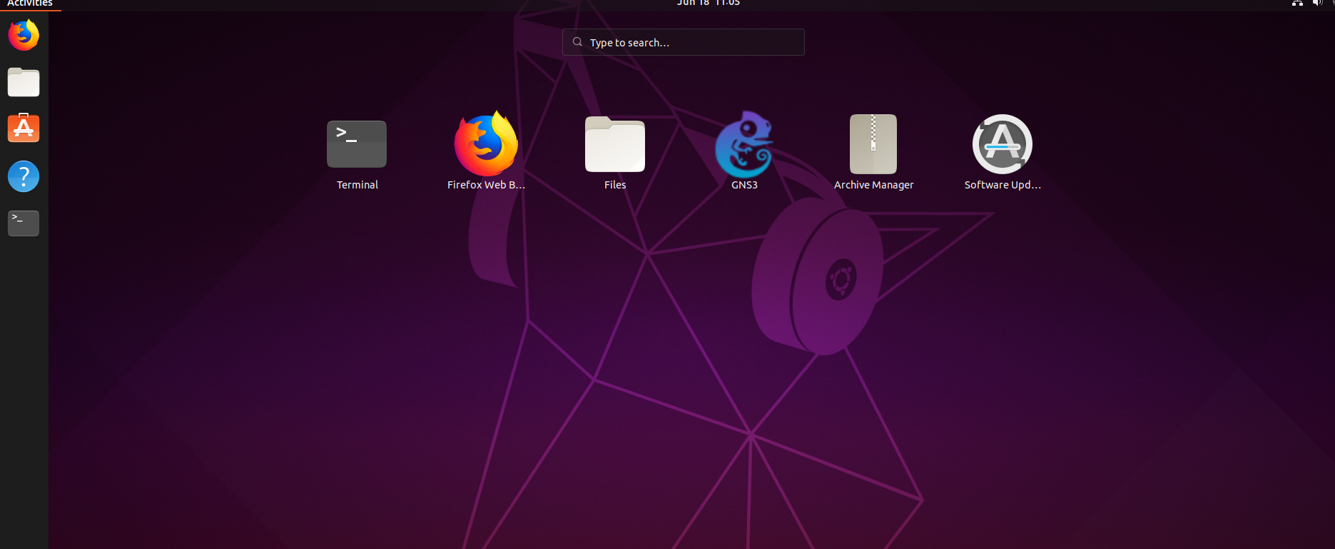

* 1. Click Next until server is done

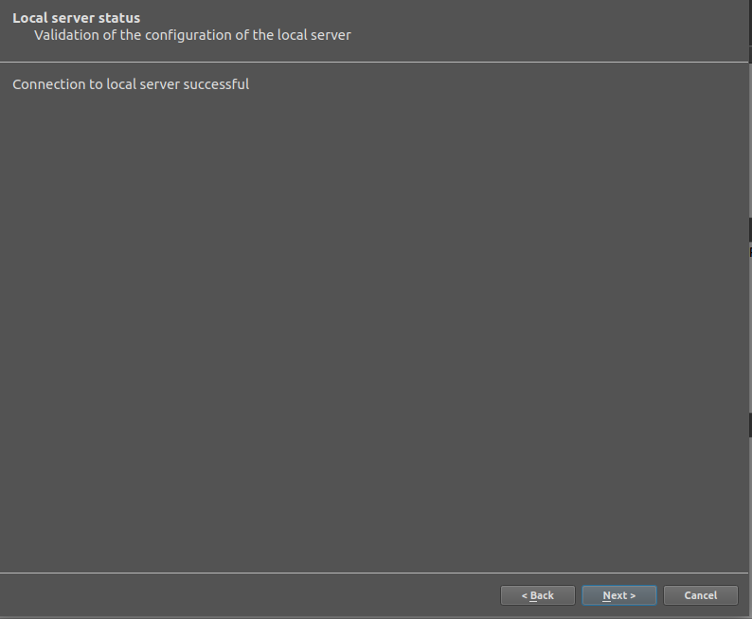

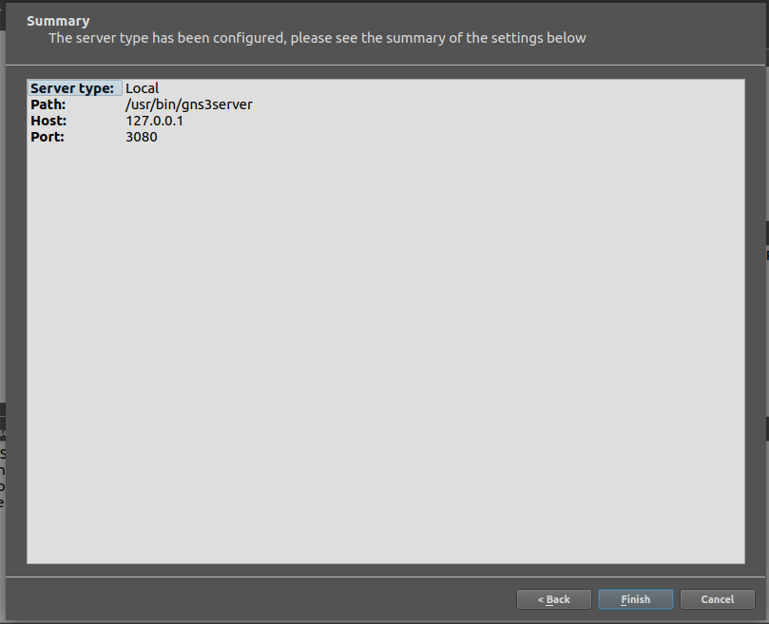

# **Integrating a router**

* 1. On a new project click the router and select the router you want to integrate

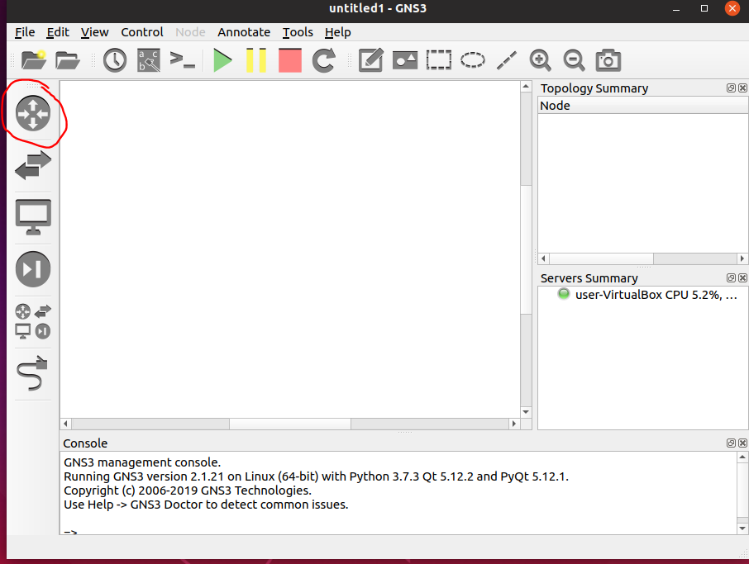

* 1. After selecting router click next and choose Run the appliance on your local computer

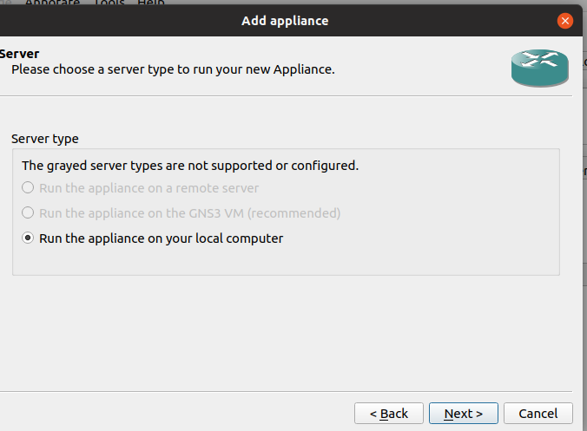

* 1. Click Create a new version

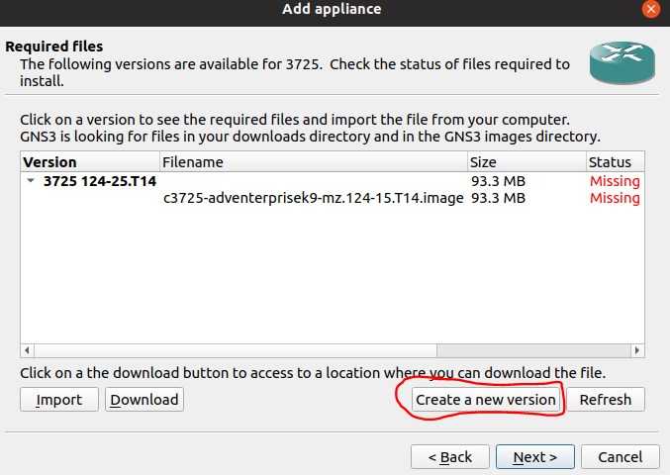

* 1. Download IOS images if not already. Copy the file name. Paste file name in box then press OK

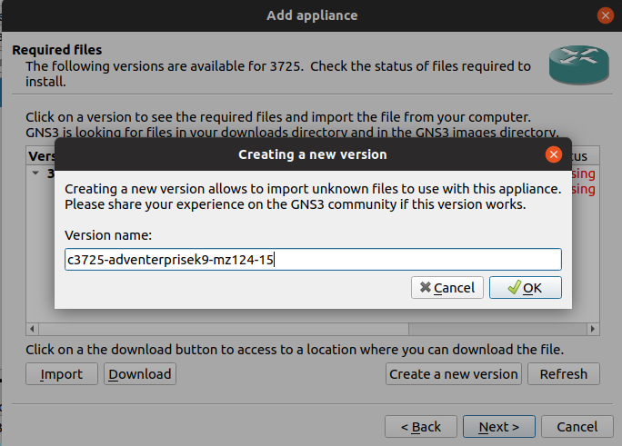

* 1. Click on the new version then click import

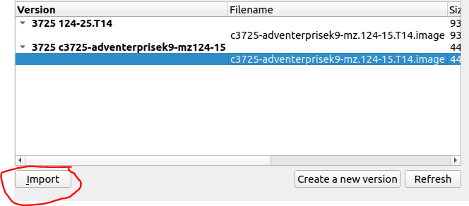

* 1. Find the IOS image then click open

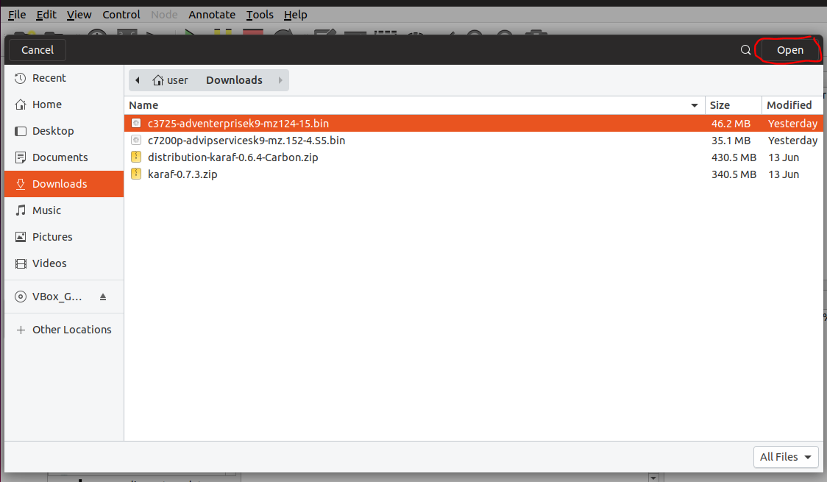

* 1. Click next and yes until you reach the end.

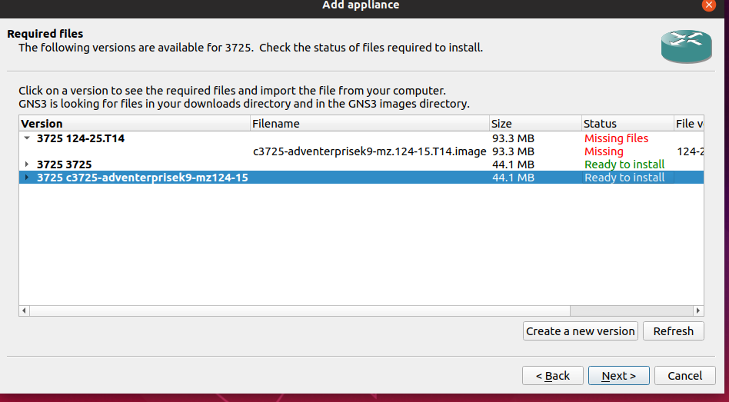

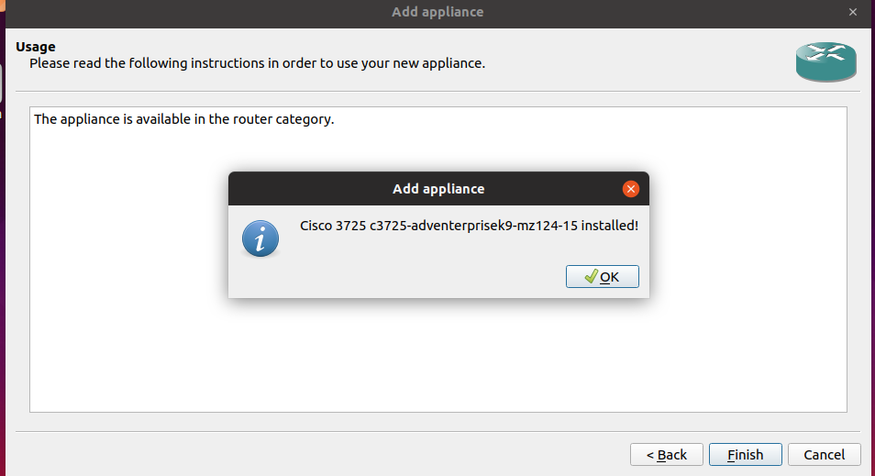

* 1. Router should now be usable

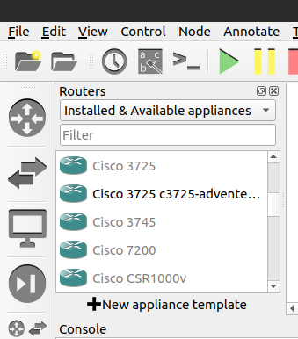

# **Setting up simple network**

1. Create a new project

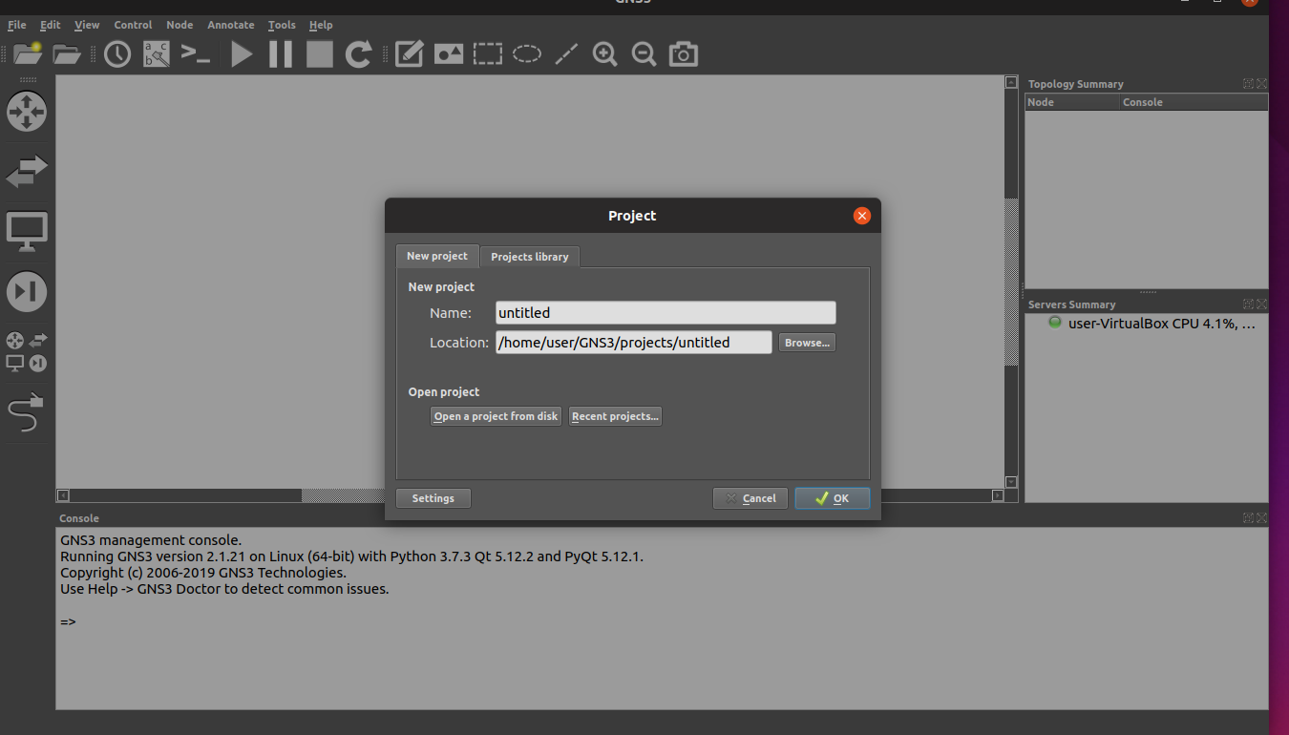

1. Add one ethernet switch and two end devices

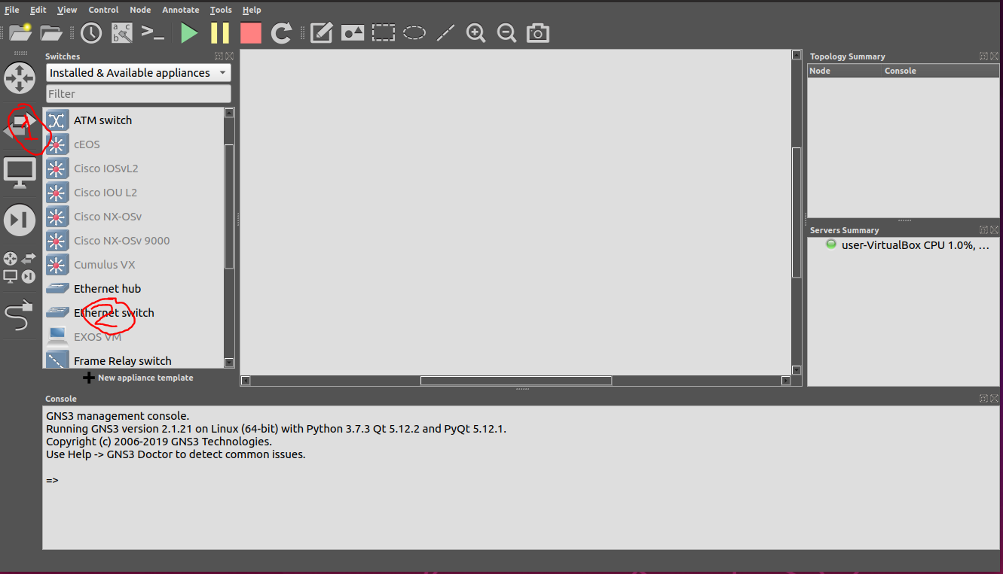

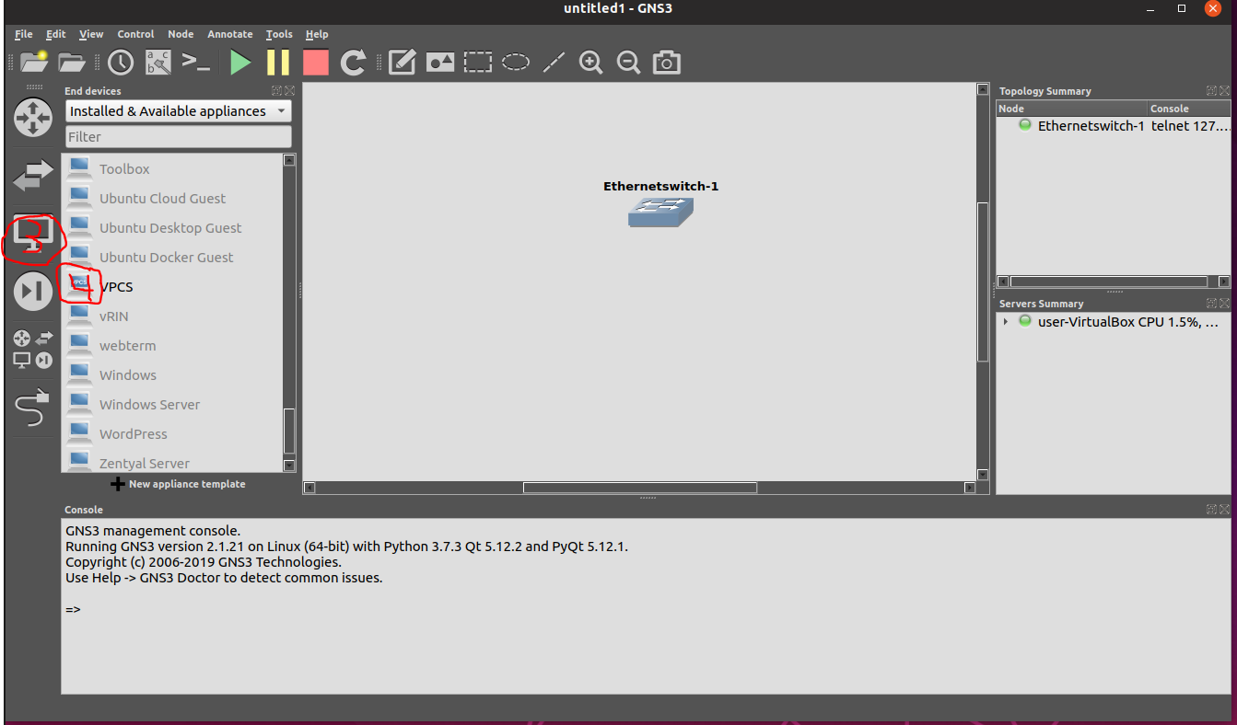

* 1. Connect them with a patch cable

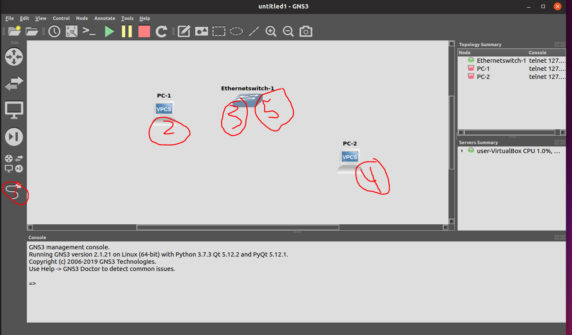

* 1. Turn on and Open console for each

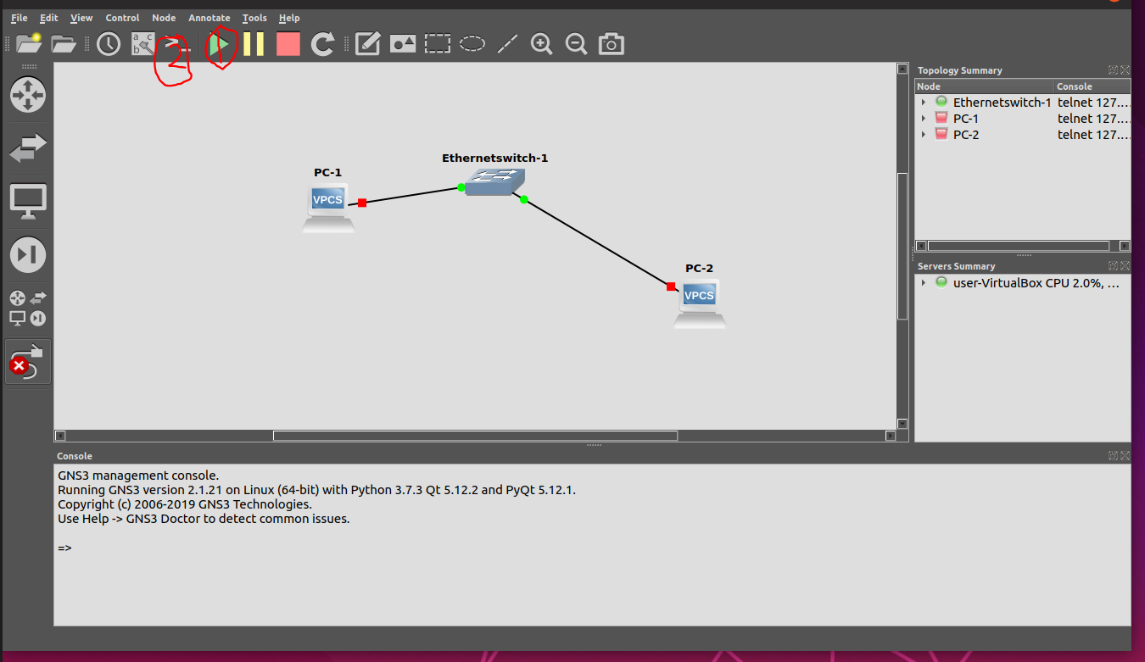

* 1. On PC-1 type in: ip 10.1.1.1 255.255.255.0
  2. On PC-2 type in: ip 10.1.1.2 255.255.255.0
  3. Confirm that they are connected
     1. On PC-1 type in: ping 10.1.1.2
     2. On PC-2 type in: ping 10.1.1.1

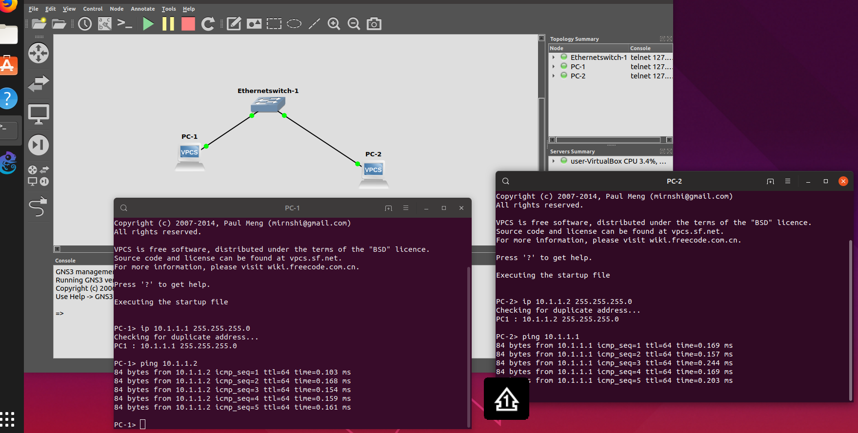

# **Fixing GNS3 Errors**

* 1. GNS3 can only be run by root.
     1. Go to terminal, delete run_as_root file

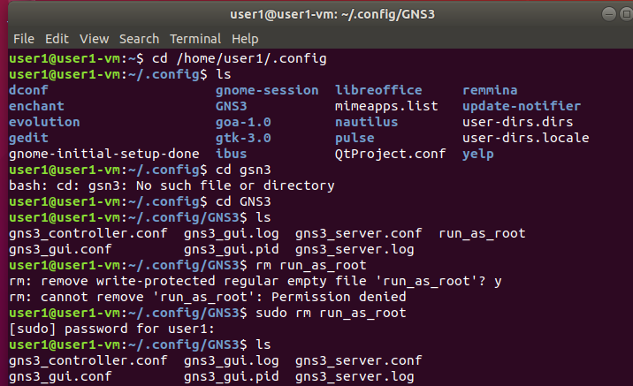

* 1. Another GNS3 GUI is already running 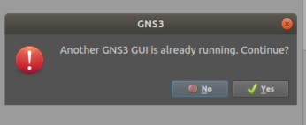
     1. Change permissions of the GNS3 folder Change permissions on the GNS3 folder in the Home directory and the .config directory.



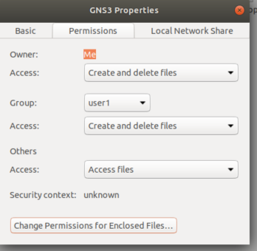

* 1. GNS3 permissions are denied 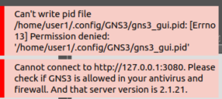

Change permissions on the GNS3 folder in the Home directory and the .config directory.





# **References**

* + - 1. <https://docs.gns3.com/1QXVIihk7dsOL7Xr7Bmz4zRzTsJ02wklfImGuHwTlaA4/index.html>
      2. <https://www.linode.com/docs/applications/containers/install-docker-ce-ubuntu-1804/>